**DAILY ONLINE ACTIVITIES SUMMARY**

|  |  |  |  |  |  |  |  |  |
| --- | --- | --- | --- | --- | --- | --- | --- | --- |
| **Date:** | **26/06/2020** | | | | | **Name:** | **NIKHIL KUMAR** | |
| **Sem & Sec** | **4thSEM. & ‘B’ SEC.** | | | | | **USN:** | **4AL19CS400** | |
| **Online Test Summary** | | | | | | | | |
| **Subject** | | **NIL** | | | | | | |
| **Max. Marks** | | **NIL** | | **Score** | | | **NIL** | |
| **Certification Course Summary** | | | | | | | | |
| **Course** | **SQL and Relational Databases 101** | | | | | | | |
| **Certificate Provider** | | | **Cognitive class** | | **Duration** | | | **5hr** |
| **Coding Challenges** | | | | | | | | |
| **Problem Statement1 :** Given start and end of a range, write a Python program to print all negative numbers in given range.  Example  Input: start = -4, end = 5  Output: -4, -3, -2, -1  Input: start = -3, end = 4  Output: -3, -2, -1 | | | | | | | | |
| **Status: Executed** | | | | | | | | |
| **Uploaded the report in Github** | | | | | **Yes** | | | |
| **If yes Repository name** | | | | | <https://github.com/Nikhil401/C-Coding/blob/master/negative_no.py> | | | |
| **Uploaded the report in slack** | | | | | **Yes** | | | |

**Certification Course Summary: Today I have taken another certification course naming “SQL and Relational Databases 101 “ and gone through the module one which includes Introduction to SQL and Relational database, Information and data models, types of relationships and mapping entities to table.**

**Snapshot is given below**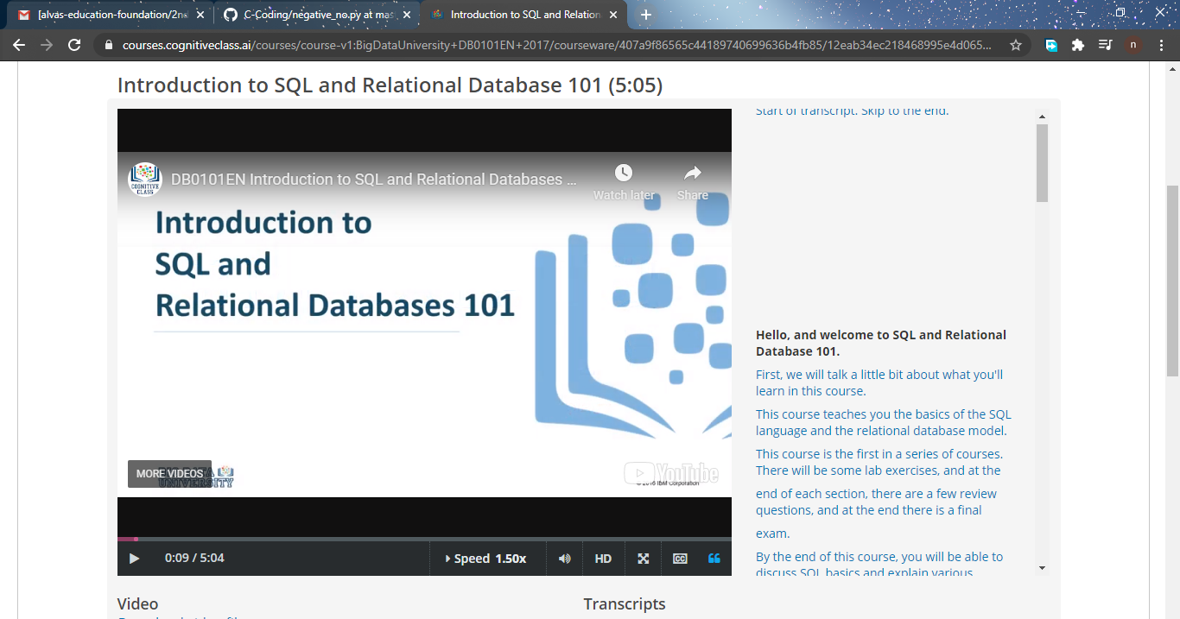

**Online Training : Today I had attended the online training organized by CSE Department AIET. The training was on Cyber security and Feature done by prof. Manjunath kotari HOD of CSE Dept. After the session the quiz was conducted.**

**And the snapshot is given below**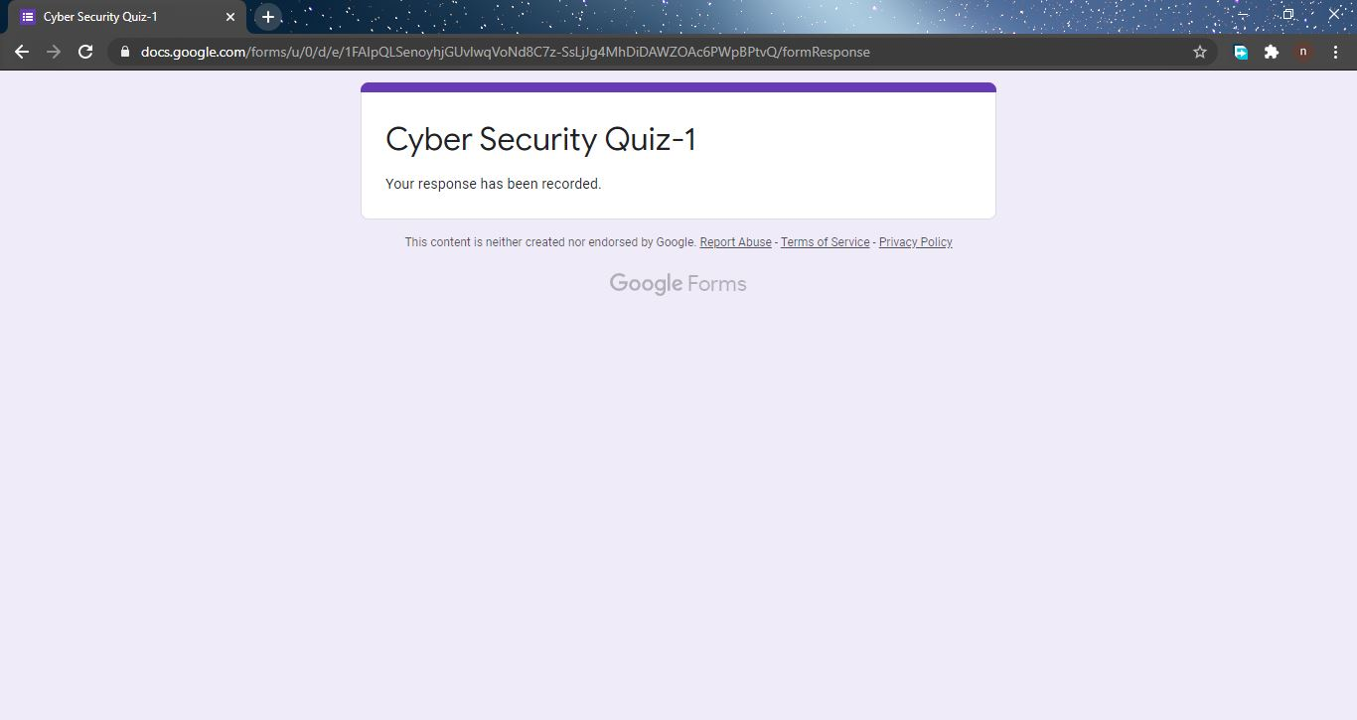

**Online coding summary: Today I had received one program which is mentioned in table above and I have uploaded into the github repository. Snapshot of the program is given below:**

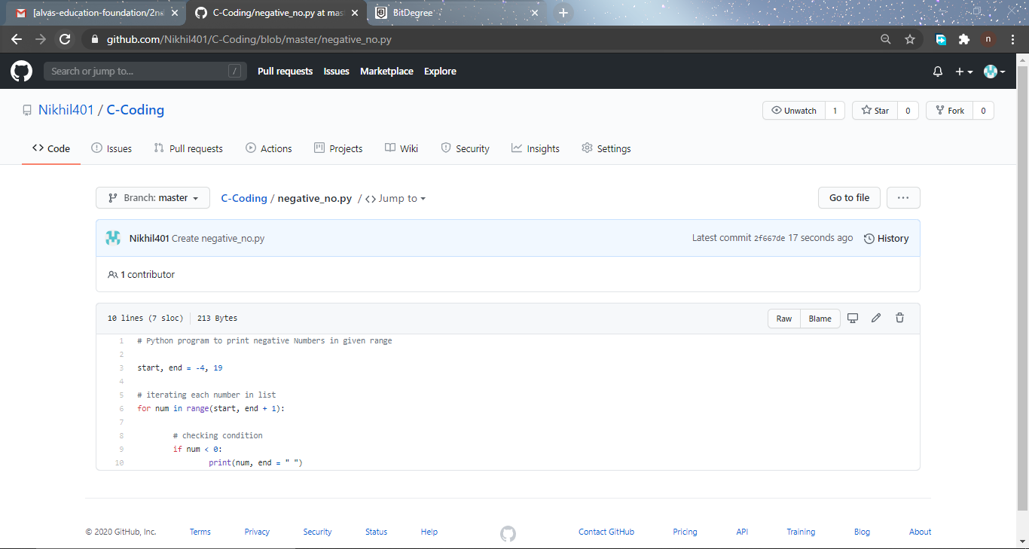 **Thank you.**